**IST 263 Project Milestone 4 – Wireframes**

**Name**: Noah Bamberger

**Description:**  
My website will be an instruction to disc golf website, intending to have all the basic information somebody needs to begin playing the sport. It will provide users with information on what the sport is, how to play it, disc types, and basic scoring and rule information. The goal is to provide new players with a base level of information to jump into the sport as the sport is growing very quickly.

**Research:**

Write down the urls of three websites you looked at to research layout for the type of site you are creating. For example, if I was creating an auction website, I might look at pages on <https://www.ebay.com/>.

|  |  |
| --- | --- |
| **url1** | [**https://www.pdga.com/news/what-disc-golf-guide-parents-kids**](https://www.pdga.com/news/what-disc-golf-guide-parents-kids)  I chose this site because it is the most likely site someone would end up on when searching disc golf basics. |
| **url2** | [**https://www.dgpt.com/news/beginners-guide-to-disc-golf/**](https://www.dgpt.com/news/beginners-guide-to-disc-golf/)  I liked the organization of this site and the images they chose, although they are not the proper aspect ratio. |
| **url3** | [**https://triggparksandrec.com/disc-golf**](https://triggparksandrec.com/disc-golf)  I liked the organization and how the creator broke up the content. |

**Wireframes:**

Use MockFlow or another diagramming software to create layouts for your pages. Consider the following:

1. Where is your navigation going to be located on every page?
2. Will you need a footer?
3. How can you make a layout that is visually interesting and helps communicate your site content?
4. Don’t forget you must have at least 2 distinctly different page layouts.

**Paste Your 3 Page Layouts Below**

**Home Page:  
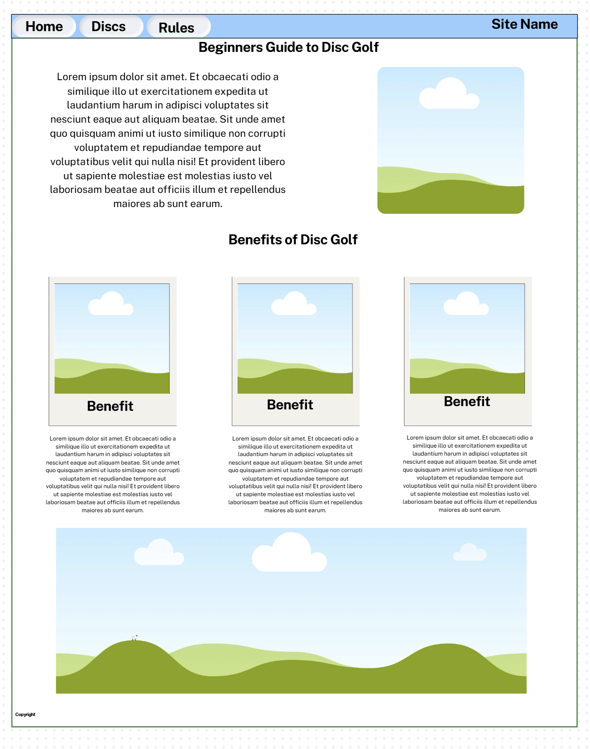**

**Disc Types Guide:**

**Basic Rules:**

